2021 Year-End Report: Oxford College
Office of Diversity, Equity, and Inclusion’s Executive Leadership Council
Report produced by Molly McGehee (Associate Dean for Faculty Development), Susan Newborn (Director of Human Resources), and Megan Pendleton (former Director of the Office of Diversity & Inclusion)

Introduction
In spite of the incredibly challenging set of circumstances—professional and personal--that all of us at Oxford College faced this past academic year, we are pleased to report that we were able to make strides in realizing our goals for diversity, equity, inclusion, and belonging at Oxford during 2020-2021. This past spring, Dean Doug Hicks built on the DEI-related work of recent years to formalize further the structure for DEI work at Oxford, with the Director of Human Resources (Susan Newborn), the former student-facing Director of Diversity, Equity, and Inclusion (Megan Pendleton, hired in March following Anthony Mize’s departure in fall 2020), and the Associate Dean for Faculty Development and Director of the Oxford Center for Teaching and Scholarship (Molly McGehee) forming a triumvirate of staff-, student-, and faculty-facing individuals who are committed and dedicated to DEI efforts at Oxford and at Emory University more broadly. As the following report will show, much has been happening at Oxford in terms of professional development and awareness-building for all of our constituents. In addition, we have begun to engage these groups in more formal conversations about campus climate and culture and to consider what additional forms of accountability we need across all groups. We continue to have much to think about and much to do, as outlined in our goals below, and we enter the new academic year with enthusiasm for the work ahead.

Oxford College Demographic Snapshots
We offer the following demographic information about students, staff, and faculty in terms of race/ethnicity, gender, and national origin as well as religious diversity and first-generation status among students.

Students
Fall 2021 Student Enrollment Data

Race/Ethnicity | 1st Year | 2nd Year | All Students
Black | 56 | 34 | 90
Hispanic | 64 | 44 | 108
Native | 0 | 0 | 0
Asian | 155 | 148 | 303
White | 211 | 141 | 352
Other/Unknown | 32 | 32 | 64
International * | 75 | 74 | 149

Sex | 1st Year | 2nd Year | All Students
Male | 283 | 216 | 499
Female | 310 | 257 | 567

 | 1st Year | 2nd Year | All Students
First Generation ** | 52 | 46 | 98

*International students are F1 visa students. **First generation definition in Admissions/Enrollment differs from that used by IPEDS. A first-generation college student is defined as a student for whom neither parent graduates from a 4-year undergraduate institution.

Fall 2020 Student Diversity (Gender, Age, Race/Ethnicity)
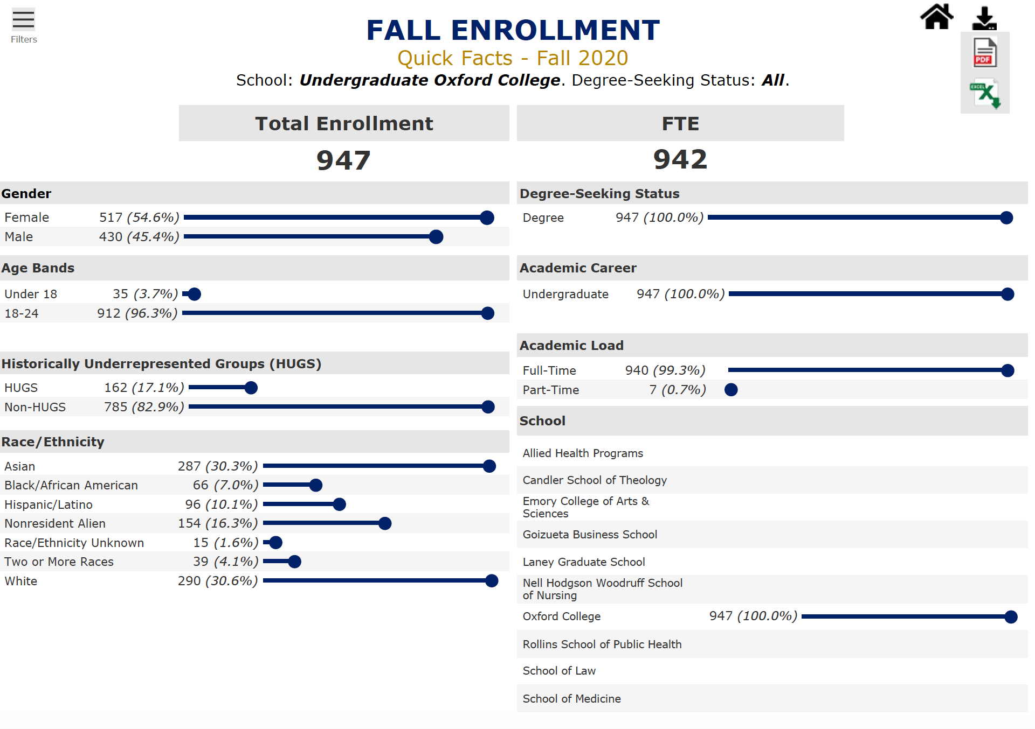
HUGS, as defined in the Emory Fact Book: Historically Underrepresented Groups (HUGS) include Black/African American, Hispanic/Latino, Native Hawaiian/Other Pacific Islander, and American Indian/Alaskan Native.

Fall 2020 Student Enrollment by Country of Citizenship
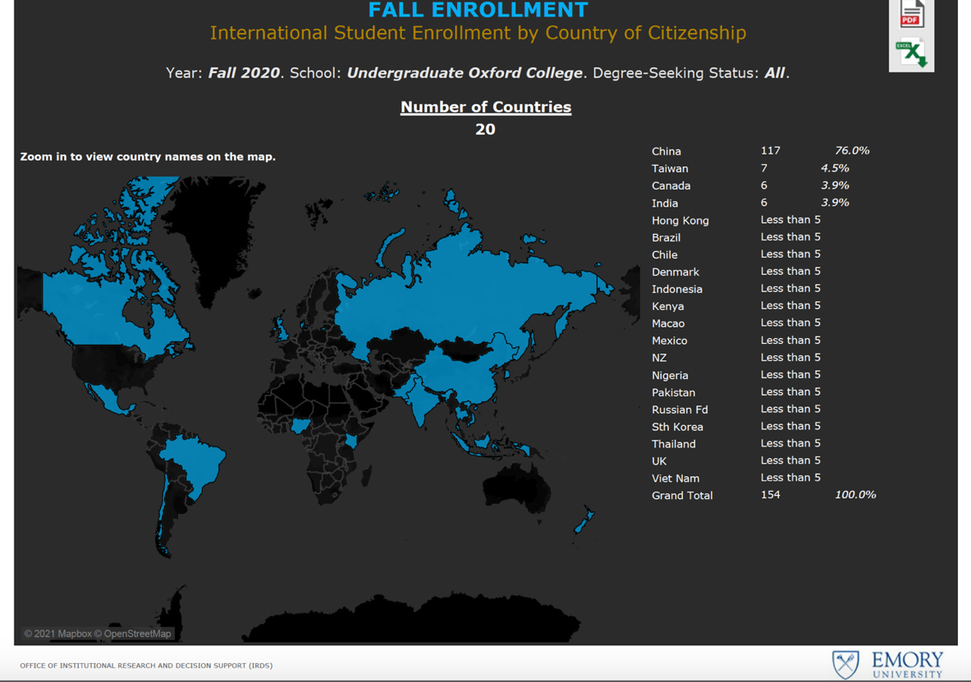
Enrollment Diversity by Race/Ethnicity, 5-Year Trends
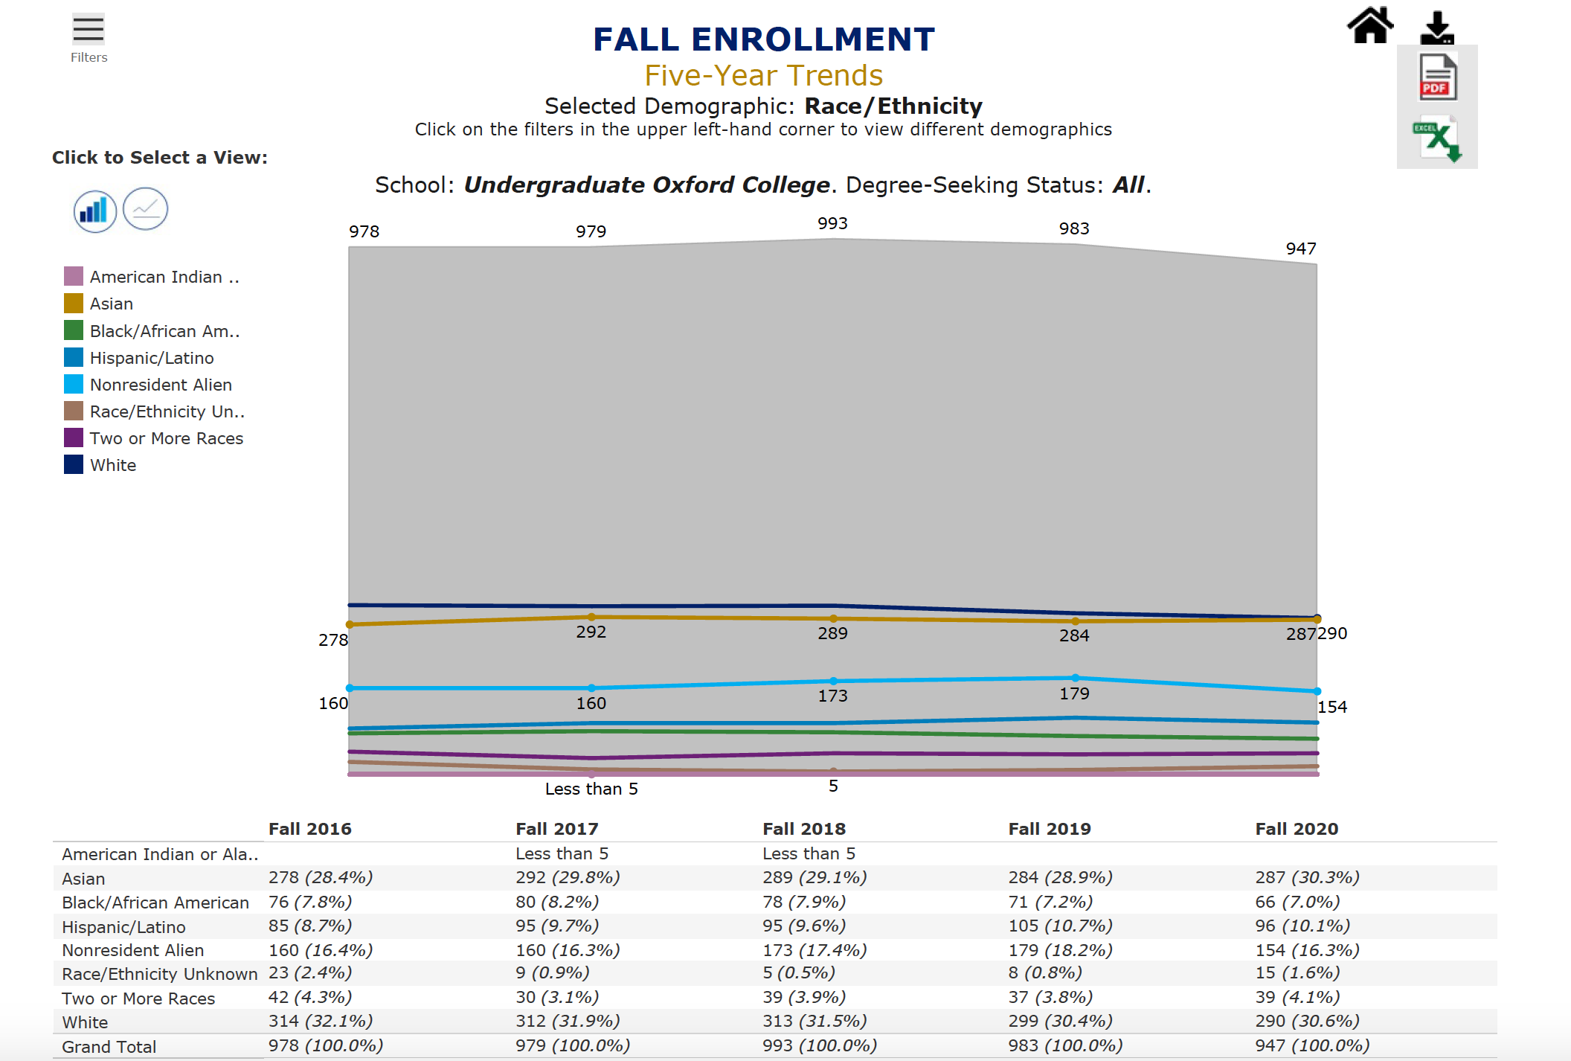

Staff Diversity (Gender, Race/Ethnicity, National Origin)
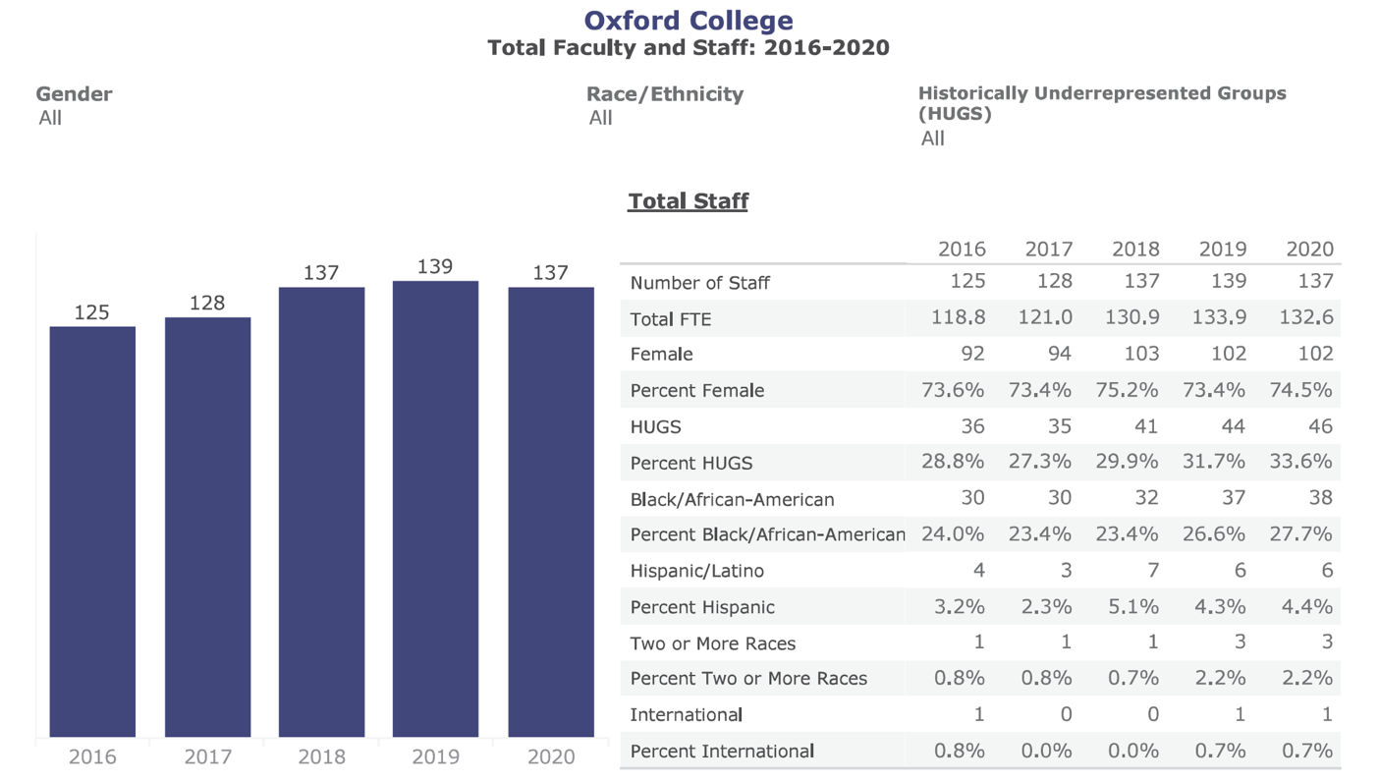

Faculty Diversity (Gender, Race/Ethnicity, National Origin)
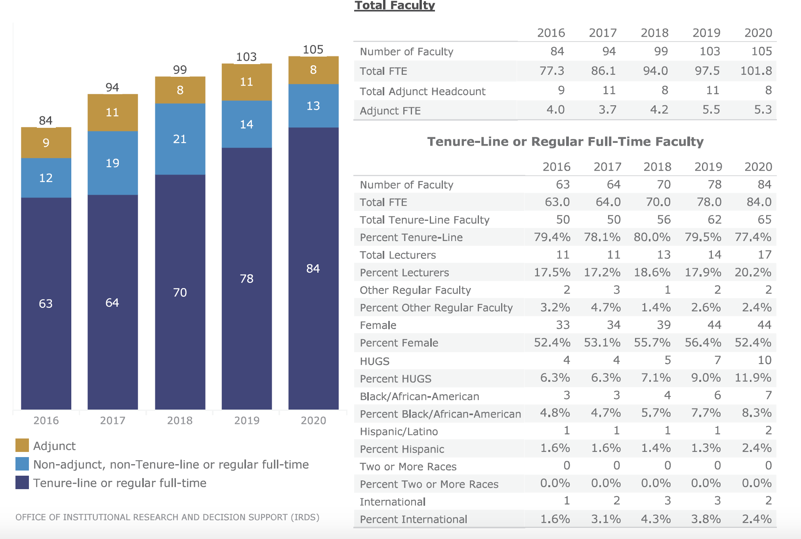

Fall 2020 Student Religious Diversity
Religion/Denomination | Number | %
Agnostic | 11 | 1%
Atheist | 11 | 1%
Bahai | 1 | 0%
Baptist | 30 | 3%
Buddhist | 13 | 1%
Church of Christ | 8 | 1%
Catholic | 91 | 10%
Christian | 43 | 5%
Christian Scientist | 1 | 0%
Congregational | 2 | 0%
Episcopal | 5 | 1%
Evangelical | 2 | 0%
Hindu | 43 | 5%
Jehovah's Witness | 1 | 0%
Jewish | 43 | 5%
Lutheran | 2 | 0%
Methodist | 29 | 3%
Mormon | 1 | 0%
Muslim | 27 | 3%
Non-Denominational | 1 | 0%
None | 525 | 55%
Orthodox | 3 | 0%
Other | 9 | 1%
Pentecostal | 8 | 1%
Presbyterian | 24 | 3%
Protestant | 1 | 0%
Quaker | 1 | 0%
Sikh | 3 | 0%
Unknown | 6 | 1%
Unitarian-Universalist | 2 | 0%
Grand Total | 947 | 100%
Source: Date of Record File

Vision and Mission
Vision
We envision an Oxford College community in which all students, staff, and faculty see themselves fully reflected in all aspects of the community and have equitable access to resources and support mechanisms that will allow them to grow and flourish within their academic and professional lives.

Mission
Oxford’s embrace of diversity, equity, and inclusion is multidimensional. We pride ourselves on the mix of people, beliefs, values, and identities that make up our campus, and on the opportunities we create to support, uplift, and care for each other. Our community is comprised of a variety of ethnicities, races, religions, socioeconomic backgrounds, gender identities, sexualities, and abilities.

The primarily student-facing Office of Diversity and Inclusion--in collaboration with the Office of Academic Affairs, Human Resources, Campus Life, the Office of International Student Programs, the Office of Religious and Spiritual Life, and many other offices on campus--provides programming and services that deepen the understanding of justice, diversity, and inclusion, support identity and cultural-based organizations, and foster community across campus, particularly for marginalized students. The office is here to help students achieve success, to educate the campus community, and foster a sense of belonging so that all students see themselves reflected at the institution in terms of curriculum, co-curricular opportunities, traditions, and mission.

The primarily faculty-facing Oxford Center for Teaching and Scholarship (OCTS) and the office of the Associate Dean for Faculty Development similarly provides a range of programming and support (financial and otherwise) to faculty to assist them in enhancing their teaching, pursuing and reaching their scholarly goals, and successfully progressing through the promotion process. Central to the efforts of OCTS is a commitment to bringing practices of inclusive teaching to the attention of all faculty, collaborating with the Center for Faculty Development and Excellence (CFDE) on such initiatives, working towards full realization of an anti-racist academic culture at Oxford, and developing plans in consultation with administrators and faculty colleagues for continued diversifying of the faculty and curriculum.

The Office of Human Resources at Oxford College works with both staff and faculty concerns regarding recruiting, hiring, and retaining the workforce. We offer our own programming, training and speakers as well as partnering with the student- and faculty-facing DEI offices to address DEI and belonging issues at Oxford and looking at promotion, salary and job content and responsibility to ensure equity.

As representatives from these three entities, our collective mission is to work collaboratively, thoughtfully, and intentionally to provide programming, resources, support, and community building opportunities to members of the Oxford community. Furthermore, we seek to ensure that all Oxford students, staff, and faculty may gain awareness and knowledge of equity-minded, justice-based, and inclusion-driven practices and develop the skills needed for implementing such practices at and beyond Oxford College.

Accomplishments and Impacts
- Professional Development, Education and Awareness
Of the three categories within this section, we placed most of our attention over the past year on providing robust professional development and educational opportunities for students, staff, and faculty. In part, this comes from our respective budgets (Campus Life, HR, Faculty Development) being primarily shaped and intended for funding programmatic and developmental opportunities for each constituency. At times this spring, however—e.g., Dr. Tameka Cage Conley’s conversation with Roxanne Gay—we found ways to collaborate in our programming and bring in additional partners (e.g., Pierce Program in Religion, Oxford College Library, and so on). All of those efforts contribute to realizing the larger goal of awareness building and consciousness raising for students, faculty, and staff. Please find below an overview of the professional development and educational initiatives we pursued for students, faculty, and staff.

For students:
- In 2016, the Inclusive Curriculum Group—comprised of faculty, staff, and students--formed to address concerns from students about the lack of diversity, especially as related to race/ ethnicity, within our curriculum. The students’ call to action and the work of the ICG in part helped fuel our hiring of faculty in the last four years within the fields of African American Studies (in collaboration with ECAS), Latin American Studies, Middle Eastern Studies/Arabic, and Women’s, Gender, and Sexuality Studies and inspire more deliberate and intentional hiring of racially and ethnically diverse faculty in a range of disciplines, including Biology, Chemistry, and Political Science. The ICG has re-formed as of this spring and is in the process of determining whether to focus solely on curricular enhancement or on broader DEI issues at Oxford. Meetings will resume this fall, and at this time, it appears that two subgroups will emerge: one focused on faculty development in terms of inclusive and anti-racist pedagogy and another on expanding and decolonizing curricular offerings.
- In addition, Oxford faculty endorsed the Race and Ethnicity general education requirement established by ECAS and began the process for soliciting and reviewing course applications, resulting in 11 courses being approved to count towards fulfillment of that requirement. OCTS also formed a discussion group for faculty interested in considering applying for this designation in the future.
- Oxford underwent a significant reform to its overall curriculum in 2017, which led to the implementation of our Discovery Seminar program (first-year seminar required for all students), Experiential Learning requirement (1 EXP course prior to graduation), and the Milestone program (ePortfolio-based reflection for students in their final semester at Oxford). A significant portion of EXP opportunities comes from Community Engaged Learning (CEL) courses—formerly known as Theory-Practice-Service Learning (TPSL)--in which students collaborate with local institutions (especially schools and afterschool programs) and make connections between their course material and their experiences. Dr. Michele Hempfling serves as Director of Community Engaged Learning and Internships, and Dr. Jill Adams serves as Director of Global Learning and Undergraduate Research. The continued formalization of this program and the contributions of Laura Gafnea, director of Community Relations, to finding opportunities for CEL for students is a significant step in breaking down historic town-gown barriers and for Oxford playing a role in serving historically underserved populations beyond its campus borders. This program builds upon Emory’s fourth pillar: Atlanta—in our case, exurban Atlanta—as a “gateway to the world.”
- Despite the fact that public lectures and performances had to be delivered on Zoom this past year, faculty and staff members went above and beyond to offer significant and meaningful programming for students, much if not most of which addressed topics related race/ethnicity, social justice, sexual orientation/ LGBTQ rights, and more.
  - The spring Lyceum series, co-sponsored by Oxford’s program in Women’s, Gender, and Sexuality Studies and Emory’s Studies in Sexualities program, was social justice themed; organized by Professors Alix Olson, Nick Fesette, and Josh Mousie, the series featured a diversity of speakers on topics ranging from the prison abolitionist movement to polyamory to moving beyond black-white binaries.
  - Several offices collaborated to host renowned writer Roxane Gay in conversation with Dr. Tameka Cage Conley (English & Creative Writing). And the Southern Circuit film series, which we have been hosting for seven years, featured a diversity of films and filmmakers with 100 attendees on average per screening (primarily students).
  - Staff members Ricardo Horne (Campus Life) and Mika Vines Culbreath (Events & Conferences) collaborated with the Black Student Association (BSA) to host several events this spring, including a presentation by several African American alums working in medical fields and a film screening/discussion of Moonlight with Molly McGehee.
- The Office of Religious and Spiritual Life, led by Oxford chaplain Rev. Dr. Lyn Pace, provided an impressive number of opportunities for education and awareness-building for the Oxford community, including the following: 30/50 celebrations in spring 2020 (activities honoring 30 years of MLK Scholars and 50 years since the first African American graduates of the college; a presentation by Valarie Kaur, civil rights activities, lawyer, and founder of the Revolutionary Love Project; a presentation by Civil Rights leader, Oxford and Emory alum, Taos Wynn. Dr. Pace is also a member of a committee on race for the City of Oxford which held a communal event (on zoom) for Black History Month in February 2021, a first for the City of Oxford. He is working on returning to an in-person MLK celebration for January 2022, and working to establish a new Inter-Religious Council at Oxford this coming academic year.
- ]Over the past three years, the Office of Diversity and Inclusion cosponsored and collaborated with cultural and identity-based organizations to host educational awareness opportunities for the campus community. This included conversations on identity and experience, as well as support for Dooley’s Dialogue, a periodic conversation series hosted by SGA, in collaboration with Campus Life and institutional entities.
- In connection with the Atlanta campus’s Office of LGBT Life, ODI coordinated Safe Space training for students, staff, and faculty to increase knowledge and awareness of issues faced by the LGBTQ community. While celebratory in nature, the acknowledgement of national history and heritage months (e.g., Black History Month, LGBTQ History Month), increases understanding of experiences of marginalized groups both on and off campus.’
- In fall 2021, Oxford students presented accepted proposals to the university's Symposium on Slavery and Dispossession to highlight the history of slavery at Oxford and the local community, current implications of that history, and connect literature to the implications of slavery in America.
- For the past two years, Oxford has included a DEI Module as a part of New Student Orientation, which is a collaborative effort with constituents on the Atlanta Campus including the Office of LGBT Life, The Center for Women, and the Office for Racial and Cultural Engagement. This module included an overview of a "Community of Care," our shared values of diversity, equity and inclusion, the benefits of an inclusive education, an introduction to common language, and information on resources and getting involved at Emory and in Atlanta. The module also included John Lewis' last essay, "Together, You Can Redeem the Soul of Our Nation," and offered students a chance to reflect on all of the module’s content.
- Leigh Elion, Director of the Writing Center, continues to create opportunities for Oxford Writing Center Consultants and Writing Fellows to learn about the connections between writing pedagogy and power, reflect on their own positionality as students and educators, and develop their own inclusive pedagogies. The following list represents a few Writing Center-related activities and changes from the past year:
  - Revision of the English 202E Writing Center Practicum syllabus to represent diverse scholars and schools of thought, with a focus on interrogating racialized myths of "standard" English; a visit in fall 2020 from scholar Nancy Alvarez to talk with students about race and translanguaging in the Writing Center (an opportunity not only for students to develop their inclusive pedagogy toolkits but also to connect non-white students with additional mentors beyond Dr. Elion); sponsorship of student staff members' attendance at online conferences and workshops that focused on topics like racial justice in writing centers, accessible online pedagogy, and disability and mental health in higher education.
  - The Oxford Writing Center offered services entirely online, adding expanded hours, to make sure that academic support was available to all students regardless of time zone or citizenship status. Making sure that academic support was available to all regardless of time zone or citizenship status what was done before the pandemic. However, the nature of pandemic travel restrictions meant that the students who were most likely to have difficulty coming to campus for residential learning last year were those who were living abroad and/or weren't US citizens (two groups that have substantial overlap but aren't necessarily one and the same). Since citizenship status is a protected category in some respects, it was important to be attentive to, at the very least, not worsening educational inequities for that group during a time when they were being excluded from some educational experiences by virtue of their immigration status.
  - This shift also allowed the Writing Center to operate in multiple modalities (video + audio, audio only, text-based chat only), an access shift that helped it enact UDLvalues.
  - Dr. Elion created Writing Center student-led mentor groups as part of staff's ongoing professional development, a choice rooted in social justice values, and she continues to revise hiring practices to make sure that the Writing Center retains a staff reflective of Oxford's diverse student body. In addition, Dr. Elion is currently developing a public-facing inclusivity statement for the Writing Center that documents how current policies and practices reflect a commitment to DEI work, names specific areas for improvement, and publicly re-affirms our commitment to meeting even more ambitious benchmarks related to student-facing instruction, hiring, and mentorship in the Oxford Writing Center.

For faculty/staff/administrators:
- Oxford College Online Teaching (OCOT) training: With the advent of the pandemic in spring 2020, we on the faculty development side had to move quite quickly to ensure faculty and student-facing staff members had what they needed for remote teaching. With financial support from the Oxford Board of Counselors, OCTS in collaboration with the Office of Academic Technology organized a 5-week training entitled Oxford College Online Teaching (OCOT); all faculty were required to participate, with a significant stipend provided to each. Rather than make this tech- or software-driven, however, we used the crisis as an opportunity to introduce all faculty to inclusive pedagogy and Universal Design for Learning (UDL). As the syllabus attached shows, faculty were introduced to (for some, it was a reminder of) the variety of ways they could make their teaching, Canvas sites, syllabi, and general approaches to students more inclusive, accessible, and accommodating. The technology followed from there.
- OCTS annual programming: Overall, introducing faculty, staff, and administrators to inclusive teaching practices has been a primary goal of OCTS in recent years. This year, we offered a range of workshops and discussions on topics such as ungrading (with speaker Susan Blum from Notre Dame), addressing students’ and one’s own emotional and mental health needs during the pandemic, and more. We had excellent attendance and participation at all sessions (30-40 attendees per session). We intend to continue such programming this year with hopes of creating an anti-racist reading and discussion group as well; planning for 2021-22 OCTS programming is currently underway.
- Our faculty are encouraged to participate in workshops/ reading groups sponsored by Emory’s Center for Faculty Development and Excellence, and we have close working relationships with Donna Troka and Allison Adams, among others, at CFDE. Faculty are also made aware of and encouraged to participate in programs hosted by the National Center for Faculty Diversity and Development.
- Prior to the pandemic, Scott Foster (Director of Academic Technology) and I were in conversation with Donna Troka at CFDE about the possibility of creating a course analytics dashboard, similar to that created by inclusive pedagogy experts Viji Sathy and Kelly Hogan at UNC-Chapel Hill, for faculty, with Oxford as a pilot site. The dashboard would allow “any instructor of undergraduate students...to access their course data. Faculty can examine course grades in aggregate along with seven different categories of student characteristics: gender, residency status, race/ethnicity, transfer status, first generation status, Pell eligibility and SAT/ACT scores. Data are presented so that individual students cannot be identified; the tool provides summary statistics only. Faculty will see data only from their own courses” (UNC’s The Well, 27 March 2019). The goal is for faculty to use their data—available only to them—to ask themselves whether their pedagocial approaches are or are not serving all students well and, if not, to consider how to adjust their teaching accordingly, perhaps in conversation with the director of OCTS or with colleageus at CFDE. We have resumed conversations with Emory colleagues in academic technology and data management about implementing such a system in the future.

For staff:
- Search committee members participate in training on how to conduct a fair and compliant search and implicit bias awareness training. During the selection process, committees are asked about the candidates they advance and why they have chosen those candidates relative to others. We ask committees to develop a standardized rubric that allows them to objectively rank and select candidates to encourage selection on tangible measures rather than ”gut feelings” and “fit.”

The efforts described above are intended to build on Emory’s first pillar of faculty excellence, especially in terms of building an inclusive intellectual community, and on the second pillar of Emory as academic community of choice. The impact of all of these efforts is somewhat difficult to gauge, and we would welcome assistance in determining how best to do so. Individual student course evaluations may speak to impact to some extent (although research points to the biases therein and shows they are not a completely reliable instrument). Recent student surveys regarding climate can be interpreted as reflective of a generally positive impact of these and other efforts and yet also suggest additional avenues for us to consider further. Faculty response to OCOT (via a survey) was overwhelmingly positive. The recent COACHE survey administered to faculty can also provide some insight into impact and areas for improvement. However, we will need to engage more fully with our director of institutional research and perhaps others at the university familiar with impact assessment to gauge the effects of our efforts and to connect those to our goals regarding climate/culture and accountability.

Professional Development, Education, and Awareness Goals:
Our overarching goals are indeed many of those suggested in the template provided to us by the ODEI: to make available to the Emory enterprise and campus community learning opportunities that will encourage intercultural fluency around the principles of diversity, equity, and inclusion; to create opportunities for self-discovery and perspective taking that allows one to understand their communal impact on others, and to understand how their own diversity helps to shape community practices, work and learning engagement, environment and culture; to acknowledge that the different dimensions of diversity create a dynamic and complex campus community and enterprise that requires continuous learning, reflection, and examination of practices, policies, cross-cultural principles and institutional infrastructures so that those practices promote and ensure the common good and the success of all regardless of title, position, status or station; and to strengthen organizational diversity competencies in ways that interrogate and remedy systemic barriers that promote inequities and/or hostile work and learning environments; and to maintain and provide an institutional web of care for all employees, students, faculty, and staff that promotes cultural literacy in ways that collaboratively builds a community of excellence centered on the holistic well-being of others, their dignity, traditions, histories and cultures.

To realize these aims more fully, we have set some specific goals/ tasks for AY 2021-22 and beyond:
- Continue to support DEI-related faculty and staff development through programming and through targeted encouragement to and funding for faculty and staff members to attend conferences and trainings related to DEI, whether in their specific discipline or within academia more broadly
- Collaborate with Communications Team to develop a webpage (or series of pages) devoted to DEI initiatives at Oxford
- Discuss pursuing dedicated funding for DEI initiatives (e.g., to allow each year for 2-3 major speakers on topics related specifically to race and ethnicity versus continuing the current practice of soliciting contributions from multiple offices to cover speaker fees)
- Collaborate with the working group on memorialization to ensure robust programming about Oxford and Emory’s history and larger contextualization for the twin memorials that are to be designed and erected
- Provide access to DEI-related material and resources via a weekly newsletter
- Collaborate on developing co-facilitated first-year student sessions on activism, advocacy, equity, and inclusion
- Continue previous trainings and development of tailored trainings for student leaders (e.g., Resident Advisors, Orientation Leaders, iMentors)
- Explore opportunities to expand the implicit bias trainings to help committees mitigate their biases and to have frank conversations among themselves about the selection process, especially regarding issues of race

- Climate and Culture
As suggested above, we have put a great deal of energy this past year into providing opportunities for development, education, and awareness raising among faculty, staff, and students. From our perspective, that is relatively “easy” work—time intensive and requiring thoughtfulness, yes, but largely transactional. The harder work we do is related to facilitating honest and productive dialogue about campus climate and culture among our respective constituencies, a climate and culture that is in many ways decades in the making—and then responding to what emerges from such conversations to transform that climate and culture for the better. In the wake of the killings of George Floyd, Breonna Taylor, and Rashard Brooks in 2020, it became clear to many of us across Oxford’s campus that we must find ways to evaluate climate and culture as specifically related to race—and even more specifically, as related to the experiences of Black students, staff, and faculty at Oxford—and to provide opportunities for colleagues to discuss such issues. This past year also made even clearer the need for Oxford, and Emory University more broadly, to address, make visible, and reckon with its history as related to Native Americans and the enslavement of African Americans. Oxford’s participation in the two task forces appointed by President Fenves has been crucial for moving those efforts forward, and there is exciting work ahead this coming year.

For students:
- For the past several years, Oxford’s Residential Education and Services office has participated in the Skyfactor Benchworks’ (formerly EBI) Residential Life and Housing Survey. Since 2015, Oxford College’s results on diverse interactions have ranked #1 amongst both similarly classified institutions, as well as all participating schools nationally. Just this month, Oxford received the 2021 Assessment & Impact Award in Housing and Residence Life from Skyfactor for this work.
- Cultural and identity-based student organizations like the Black Student Alliance, OxFirst (First Generation & Low Income), Ola, Revision, and Oxford Chinese Student Association--just to a name a few--foster experiences for students with marginalized identities, build community, and collaborate with Campus Life entities to enhance the culture on campus and with the Student Government Association to advocate for needed change.
- Mindsets 2.0, a revamped and collaborative set of principles to encourage critical thinking, inclusive practices, and collective ways of being, offers a holistic toolkit for approaching student development, community values, and collective mindsets. Students, staff, and faculty will have continued access to this resource for their use. Going forward, Rhiannon Hubert and Ami Hernadez will develop measurement tools and ways to assess the impact of this program on students.
- More advanced, collaborative, and extensive planning, recognition, and celebration for Affinity/ Heritage Months to foster a climate that centers experiences of marginalized community members, historical contexts that inform current practice, and highlights contributions, efforts, and needs of the community. In past years this has included a collaborative and campus wide celebration of Black History Month, participation at the Atlanta Pride Parade, and celebration of MLK Day.
- Oxford’s Counseling and Career Services Center (CCS), under the direction of Dr. Gary Glass, has promoted an understanding of mental health that explicitly integrates a social justice framework that locates student struggle in the context of systemic oppression and toxic norms. Outreach from this office includes providing programs that direct attention to intersections of social justice concerns and student distress, providing support and/or training to student organizations hosting such programming, and engaging with student leaders of various affinity groups and identity-based communities. The contributions of Dr. Glass and his team to student well-being in recent months cannot be overstated.
- The Office of International Student Programs (ISP) hosts a variety of programs to support international students on campus. The International Student Welcome (ISW), led by iMentors (student leaders), builds community, connects international students to resources, and eases their transition to the Oxford community. ISW also includes a Parents’ Program, which features presentations from Dean Hicks as well as a community dinner with families, students, and available faculty and staff. The iMentor program equips current international students with leadership skills and resources to welcome new international students to campus. In addition, ISP hosts an International Student Advisory Board, supports cultural clubs, and facilitates an International Education Week. These initiatives cultivate additional programming for international students, offer advising support for student organizations, and celebrate international education, respectively. Prior to the pandemic, ISP also organized the NAFSA Advocacy Event in Washington, DC.
- The Office of Religious and Spiritual Life, led by Rev. Dr. Pace, offered a number of morale-building opportunities for students this past year. Take a Break Tuesdays (snacks, swag, and support provided outside our Student Center every Tuesday, in collaboration with various offices to feature special programming on voter registration, international education week, academic advising and support, and gratitude station) took place on 11 Tuesdays in Fall 2020, with 50-75 students attending each time, and on 14 Tuesdays in Spring 2021, with 75-100 students attending each time. For the Faith in the Vaccine Project, along with other colleges across the US and affiliated with the Interfaith Youth Core, OSRL recruited fifteen students to participate in a summer and fall cohort building trust in communities to get the COVID-19 vaccine. They helped staff more than 15 clinics (some were part of food distribution programs, etc.). Some clinics saw five people vaccinated while others saw 20 or more. ORSL also participated in Healing Through the Arts; facilitated with the Atlanta campus Office of Spiritual and Religious Life, students from both campuses addressed the grief experienced as part of the COVID-19 pandemic as well as racial and other injustices. saw 46 submissions on Instagram. The Instagram site has 946 followers. Most posts saw anywhere from 50-75 likes, demonstrating good engagement with the project.
- The Office of Religious and Spiritual Life also coordinates 11 religious and spiritual life groups (and their religious affiliates/campus ministers if applicable), resources and advises them, and supports their efforts throughout the year. These groups offer regular and diverse weekly practice as well as episodic holy days and holidays observed. Part of the richness of our campus diversity is displayed in our religious and spiritual diversity, and the regular practices of these groups are robust and meaningful. The groups embody inclusive practices by welcoming in those from other traditions and no tradition to observe and participate in many of their practices or events. Many of them hold discussions following their practices for deeper conversation and to give those visiting an opportunity to ask questions. They strengthen our community through their regular practices of worship, prayer, study, and holiday observances and even more so through these discussions.

For faculty/staff/administrators:
- Over the last year, Susan Newborn, Pearl Dowe (African American Studies), Alix Olson (WGSS), Molly McGehee, and others organized Zoom-based discussions for both Oxford’s faculty/staff members of color (facilitated by Dr. Pearl Dowe) and white colleagues about allyship, one facilitated by Dr. Alix Olson and the second featuring a presentation by and discussion led by Dr. Donna Troka from CFDE and facilitated by faculty/ staff members. The groups met separately each time, and the attendance at each was quite high (50-70 people). We will continue to discuss how to bring the groups together in a thoughtful, well organized, and productive way to discuss emerged from the respective discussions.
- Dean Doug Hicks, Dean Molly McGehee, and Oxford alumna Avis Williams participated this year in the Task Force on Untold Stories and Disenfranchised Populations; Dr. Salmon Shomade (Political Science) participated in the University Committee on Naming Honors. The efforts of the task forces have resulted in the creation of a working group, led by Dean Hicks and Dr. Greg Ellison of Candler School of Theology, to lead memorialization efforts and programming related to Oxford’s history of enslavement and to the renaming of Oxford’s Language Hall in honor of the late Honorable Horace J. Johnson, Jr., a longtime judge in Covington and an Oxford alumnus.
- In addition, Dr. Pearl Dowe, who holds a joint appointment in African American Studies at Oxford and Emory College, currently serves on the ECAS Race and Ethnicity requirement implementation committee and on the faculty subcommittee of the DEI Strategic Planning Process Committee. She was also instrumental in collaborating with the Division Chairs in Humanities and History/Social Sciences and with Deans Ken Anderson and Molly McGehee on putting forth a proposal for a group hire in African American Studies.

For staff:
- As mentioned above, during the summer of 2020, Oxford HR hosted a set of conversations for faculty and staff of color to share their feelings about the incidents and how they affected them. Faculty and staff from different backgrounds shared experiences with common threads of what it means to be a person of color in America and found safe space to express themselves. A similar set of conversations for those who wish to be allies of POCs was also hosted. It is our hope to synthesize the findings from the conversations into a meaningful and actionable document for Oxford to make progress in addressing race, class and community on our campus.
- We actively seek opportunities for a diverse group of staff to participate in the Emory Learning and Organizational Development programs. We know that there is visibility and status inherent in participation and know that development is valuable to advance the staff careers. Excellence Through Leadership, Aspiring Leaders, Emerging Leaders can provide valuable exposure for those selected and we are intentional about providing opportunity and access to diverse staff.
- Currently, there is no formal career pathing happening. We have advocated that "time in position" and solid performance be a driver for reclassifications and promotions to elevate positions. This creates advancement opportunities within departments and Oxford. In spring 2021 we re-evaluated positions in Enrollment Services. In fall 2021 we did the same in Student Involvement and Leadership (SIL) and HR. We are also looking at OCIT's structure and have made some changes in Finance.
- Last year we elevated the DEI coordinator position to a director level position to signal to the campus, students, faculty and staff the value Oxford places on the position and on DEI within the institution.

Climate and Culture Goals
As with the professional development, education, and awareness goals shared above, our overarching goals for climate and culture mirror many of those shared in the report template. We will continue to foster an inclusive, equitable, and diverse campus community that promotes intellectual engagement, learning, and working in productive and impactful ways; to evaluate, correct, and eradicate systemic issues, barriers, and/or practices that impede fairness, access, equity and equality embedded in institutional policies, practices, protocols, and procedures; to advocate for equal employment opportunity for all employees and applicants without regard to race, color, religion, ethnic or national origin, gender, genetic information, age, disability, sexual orientation, gender identity, gender expression, veteran's status, or any other factor that is a prohibited consideration under applicable law; to promote and advocate for the recruitment and retention of accomplished and talented faculty, staff, undergraduate students, and employees from diverse backgrounds, experiences, and identities to fulfill our institutional mission to “create, preserve, teach, and apply knowledge in the service of humanity.” With these goals in mind, we offer the following specific goals/tasks for the 2021-22 AY and beyond.

For students:
- Coordinate advisory group to gain insight into issues, concerns, and ideas that the Office of DEI could address
- Fortify collaborative efforts amongst Oxford campus departments to continue creating meaningful DEI program for students
- Facilitate transportation to the Atlanta campus for DEI-related programs and events

For faculty/ staff:
- Continue to work with administrators and faculty colleagues to develop a plan for recruiting and retaining faculty of color in particular and continue to evaluate curricular offerings and to identify what fields of study need to be added or enhanced
- Continue to provide educational opportunities for faculty and staff on inclusive pedagogical and antiracist pedagogical approaches to teaching

- Accountability
Now that we have the beginning of a more formalized structure for DEI efforts, we believe that we are better poised at Oxford to ensure accountability going forward, especially with purposeful collaboration among the three of us as representatives of student, staff, and faculty arenas. Currently, accountability for/ on behalf of various constituencies typically emerges from the following formal mechanisms.

For students:
- Oxford Speak UP
- Various surveys administered by the Office of Institutional Research
- Title IX Office and Coordinators
- Title IX, DEI, and Bystander onboarding for new students
- SGA open forums and Student Concerns Committee

For faculty:
- Oxford Faculty Advisory Council (body of elected tenured professors who are available to receive confidential concerns from faculty colleagues and share those with administrative parties as deemed necessary/ appropriate). As any concerns expressed to FAC are confidential, the authors of this report do not know of trends or themes that have emerged or if any faculty colleagues approached FAC with DEI-related concerns last year).
- Annual reviews of faculty, including the submission of review portfolios (including student evaluations) by untenured and lecture-track faculty members
- COACHE survey and other surveys administered by the college/university
- Implicit bias training for faculty involved in searches

For staff:
- Human Resources mechanisms for addressing complaints related to discrimination and harassment
- Performance management reviews
- Exit interviews

Having mentioned such mechanisms, we do think it important to highlight that student course evaluations (delivered through the primarily quantitative IDEA form) do not include a significant number of questions related specifically to DEI and that much research has pointed to the flaws with course evaluations, especially in terms of demonstrated racial and gender biases towards female professors and professors of color. Additional documentation figures into the evaluation of faculty members’ excellence in teaching, of course, but we would like to have further conversations among faculty about the evaluative instrument we use (including in comparison to ECAS’s evaluation forms) and the best ways to obtain feedback from students regarding DEI approaches within our classes. (In fact, we feel this is a topic worth discussing across the undergraduate units.)

Additionally, we would welcome further conversations with various units regarding pay equity among staff across the university. In terms of promotion opportunities, creating career ladders within a department or division that are based on time in service and performance will help raise rates of pay and standards of living for staff and provide advancement opportunities without having to leave Oxford.
The existing performance management instrument asks employees and managers to rate the employee on their approach to diversity, equity, and inclusion. However, managers may not be equipped to rate this competency. There may not be opportunities for these conversations and there may be a degree of discomfort with these conversations. It will be helpful to discuss with the new director of DEI in central HR how they can help divisions approach DEI conversations within the context of performance management.

Oxford rates well with employees related to exit interviews as a place that they would recommend family and friends to work. The interview questions could be revised to ask one or two more detailed questions about the employee experience regarding DEI and belonging--so that we have a more valid measure of how our actions are impacting staff--and then to make adjustments accordingly.

Accountability Goals
Again, as with the other goals identified above, Oxford’s goals for accountability mirror several of the goals suggested within the report template, and in fact, public scholarship is already deemed a worthy evaluative category within our promotion guidelines for faculty. The general accountability goals include: to conduct prompt, unbiased review and adjudication of discrimination and harassment complaints; to create interventions for and to promotion/career ladders at all levels of the campus for staff and faculty; to see mentoring of historically underrepresented and underserved students, first generation, and students in general as more than service but teaching as well; and to promote equity within service, salary, and teaching reviews. To realize these aims, we offer several specific goals/tasks for AY 2021-22 and beyond.

For students:
- Launch the Mindsets 2.0 initiative (which features accountability as one of six central principles)
- Center accountability in DEI student leader trainings (e.g. RAs, Orientation Leaders, iMentors, etc.)
- Integrate accountability in student staff development, educational awareness activities, and programmatic endeavors

For faculty:
- Work with Oxford academic leadership to determine how best to revise the Oxford Faculty Handbook to pay more attention to and give credit to faculty for contributing to DEI work at the college and university levels (including incorporating, as ECAS has already done, a DEI-focused section within Facet, the faculty annual review online platform)
- Begin conversations with faculty about Oxford’s student course evaluation tool both in terms of potential bias and in terms of DEI-related assessment

For staff:
- Discuss with the new director of DEI in central HR how to help divisions approach diversity conversations within the context of performance management
- Revise exit interview questions to include more detailed questions about the employee experience regarding DEI
- Hold vendors accountable in the representation of leadership on our campus

For all:
- Develop a charter for our diversity leadership group and for the college

We are looking forward to the year ahead and to further collaboration with the Emory Office of Diversity, Equity, and Inclusion. Our thanks to the many individuals who contributed to this report: Ken Anderson, Travis Culver, Leigh Elion, Gary Glass, Doug Hicks, Katherine McGuire, Valerie Molyneaux, Joe Moon, Daphne Orr, and Lyn Pace.

Attachments (to be included in a OneDrive folder)
Note: These attachments are not intended for inclusion on the ODEI website but are simply provided for ODEI’s reference.

Programming: OCOT syllabus; Social Justice Lyceum Series flyer; flyers from various Campus Life events for students; and more

Student survey results: Inclusive Curriculum student survey, Spring 2016; Campus Climate Survey, Spring 2020

